1. Format all cells -> Autofit column width
2. No duplicates found
3. Delete STOP column as it is entirely empty
4. Every entry in DESCRIPTION has ‘(physical object)’ as suffix – remove for added readability

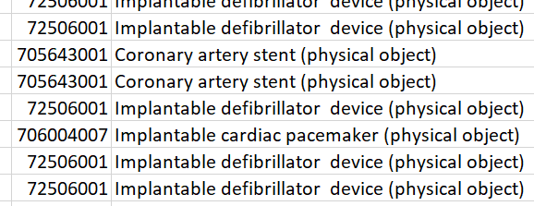

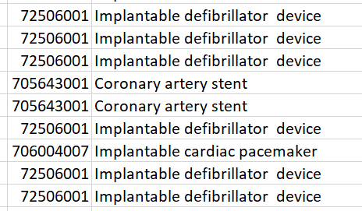

1. Remove unwanted spaces using TRIM()

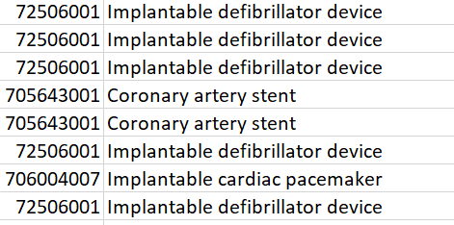

1. UDI is currently in GS1 Application Identifier format

Break it down to an understandable format –

(01) → GTIN (14 digits)

(11) → Production date (YYMMDD)

(17) → Expiry date (YYMMDD)

(10) → Lot number (variable length)

(21) → Serial number (variable length, till end)

Ex: (01)71767722231489(11)730628(17)980713(10)6519210(21)83508

(01)71767722231489 → GTIN (Global Trade Item Number, 14 digits)

(11)730628 → Production date (YYMMDD = 1973-06-28)

(17)980713 → Expiration date (YYMMDD = 1998-07-13)

(10)6519210 → Lot/Batch number

(21)83508 → Serial number

Adding corresponding columns and extracting data –

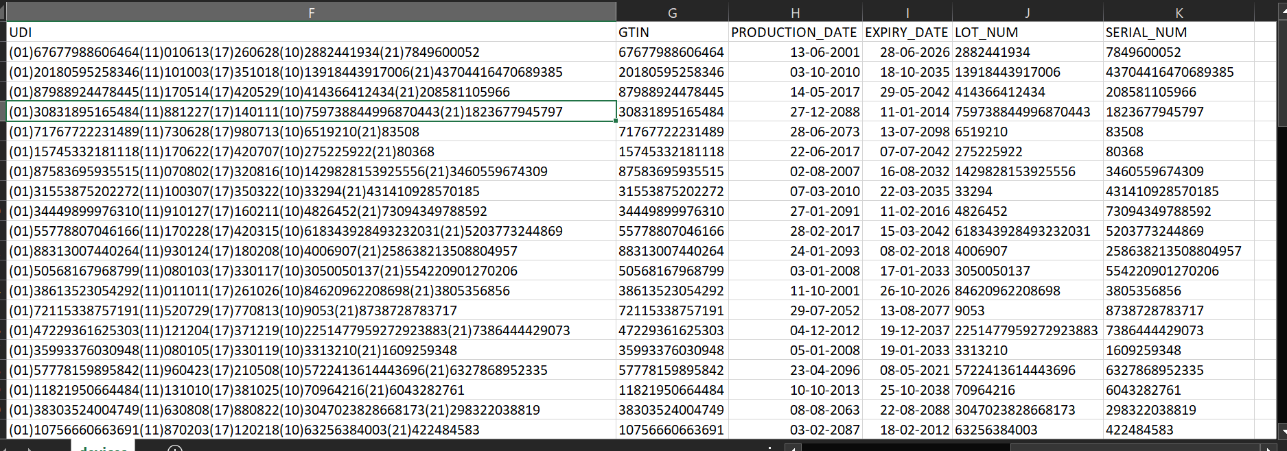

Creates invalid date ranges (some expiry < production)

New assumption – year starts from 19 if yy>50 (eg 1998), otherwise starts from 20 (eg 2011)

Using formula for production date –

=LET(

raw,MID(F2,FIND("(11)",F2)+4,6),

yy,VALUE(LEFT(raw,2)),

mm,VALUE(MID(raw,3,2)),

dd,VALUE(RIGHT(raw,2)),

yr,IF(yy+1900<1950,yy+2000,yy+1900),

DATE(yr,mm,dd)

)

Corrected values –

